Bereavement Supports



- Kildare Bereavement Network

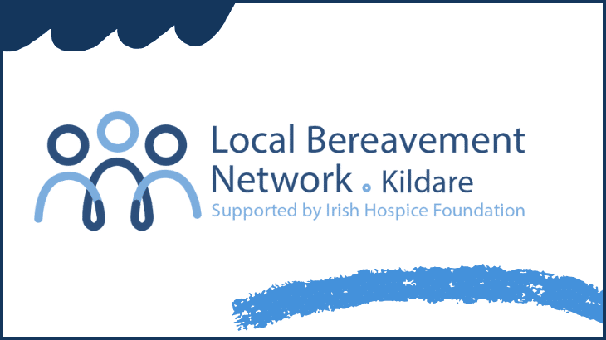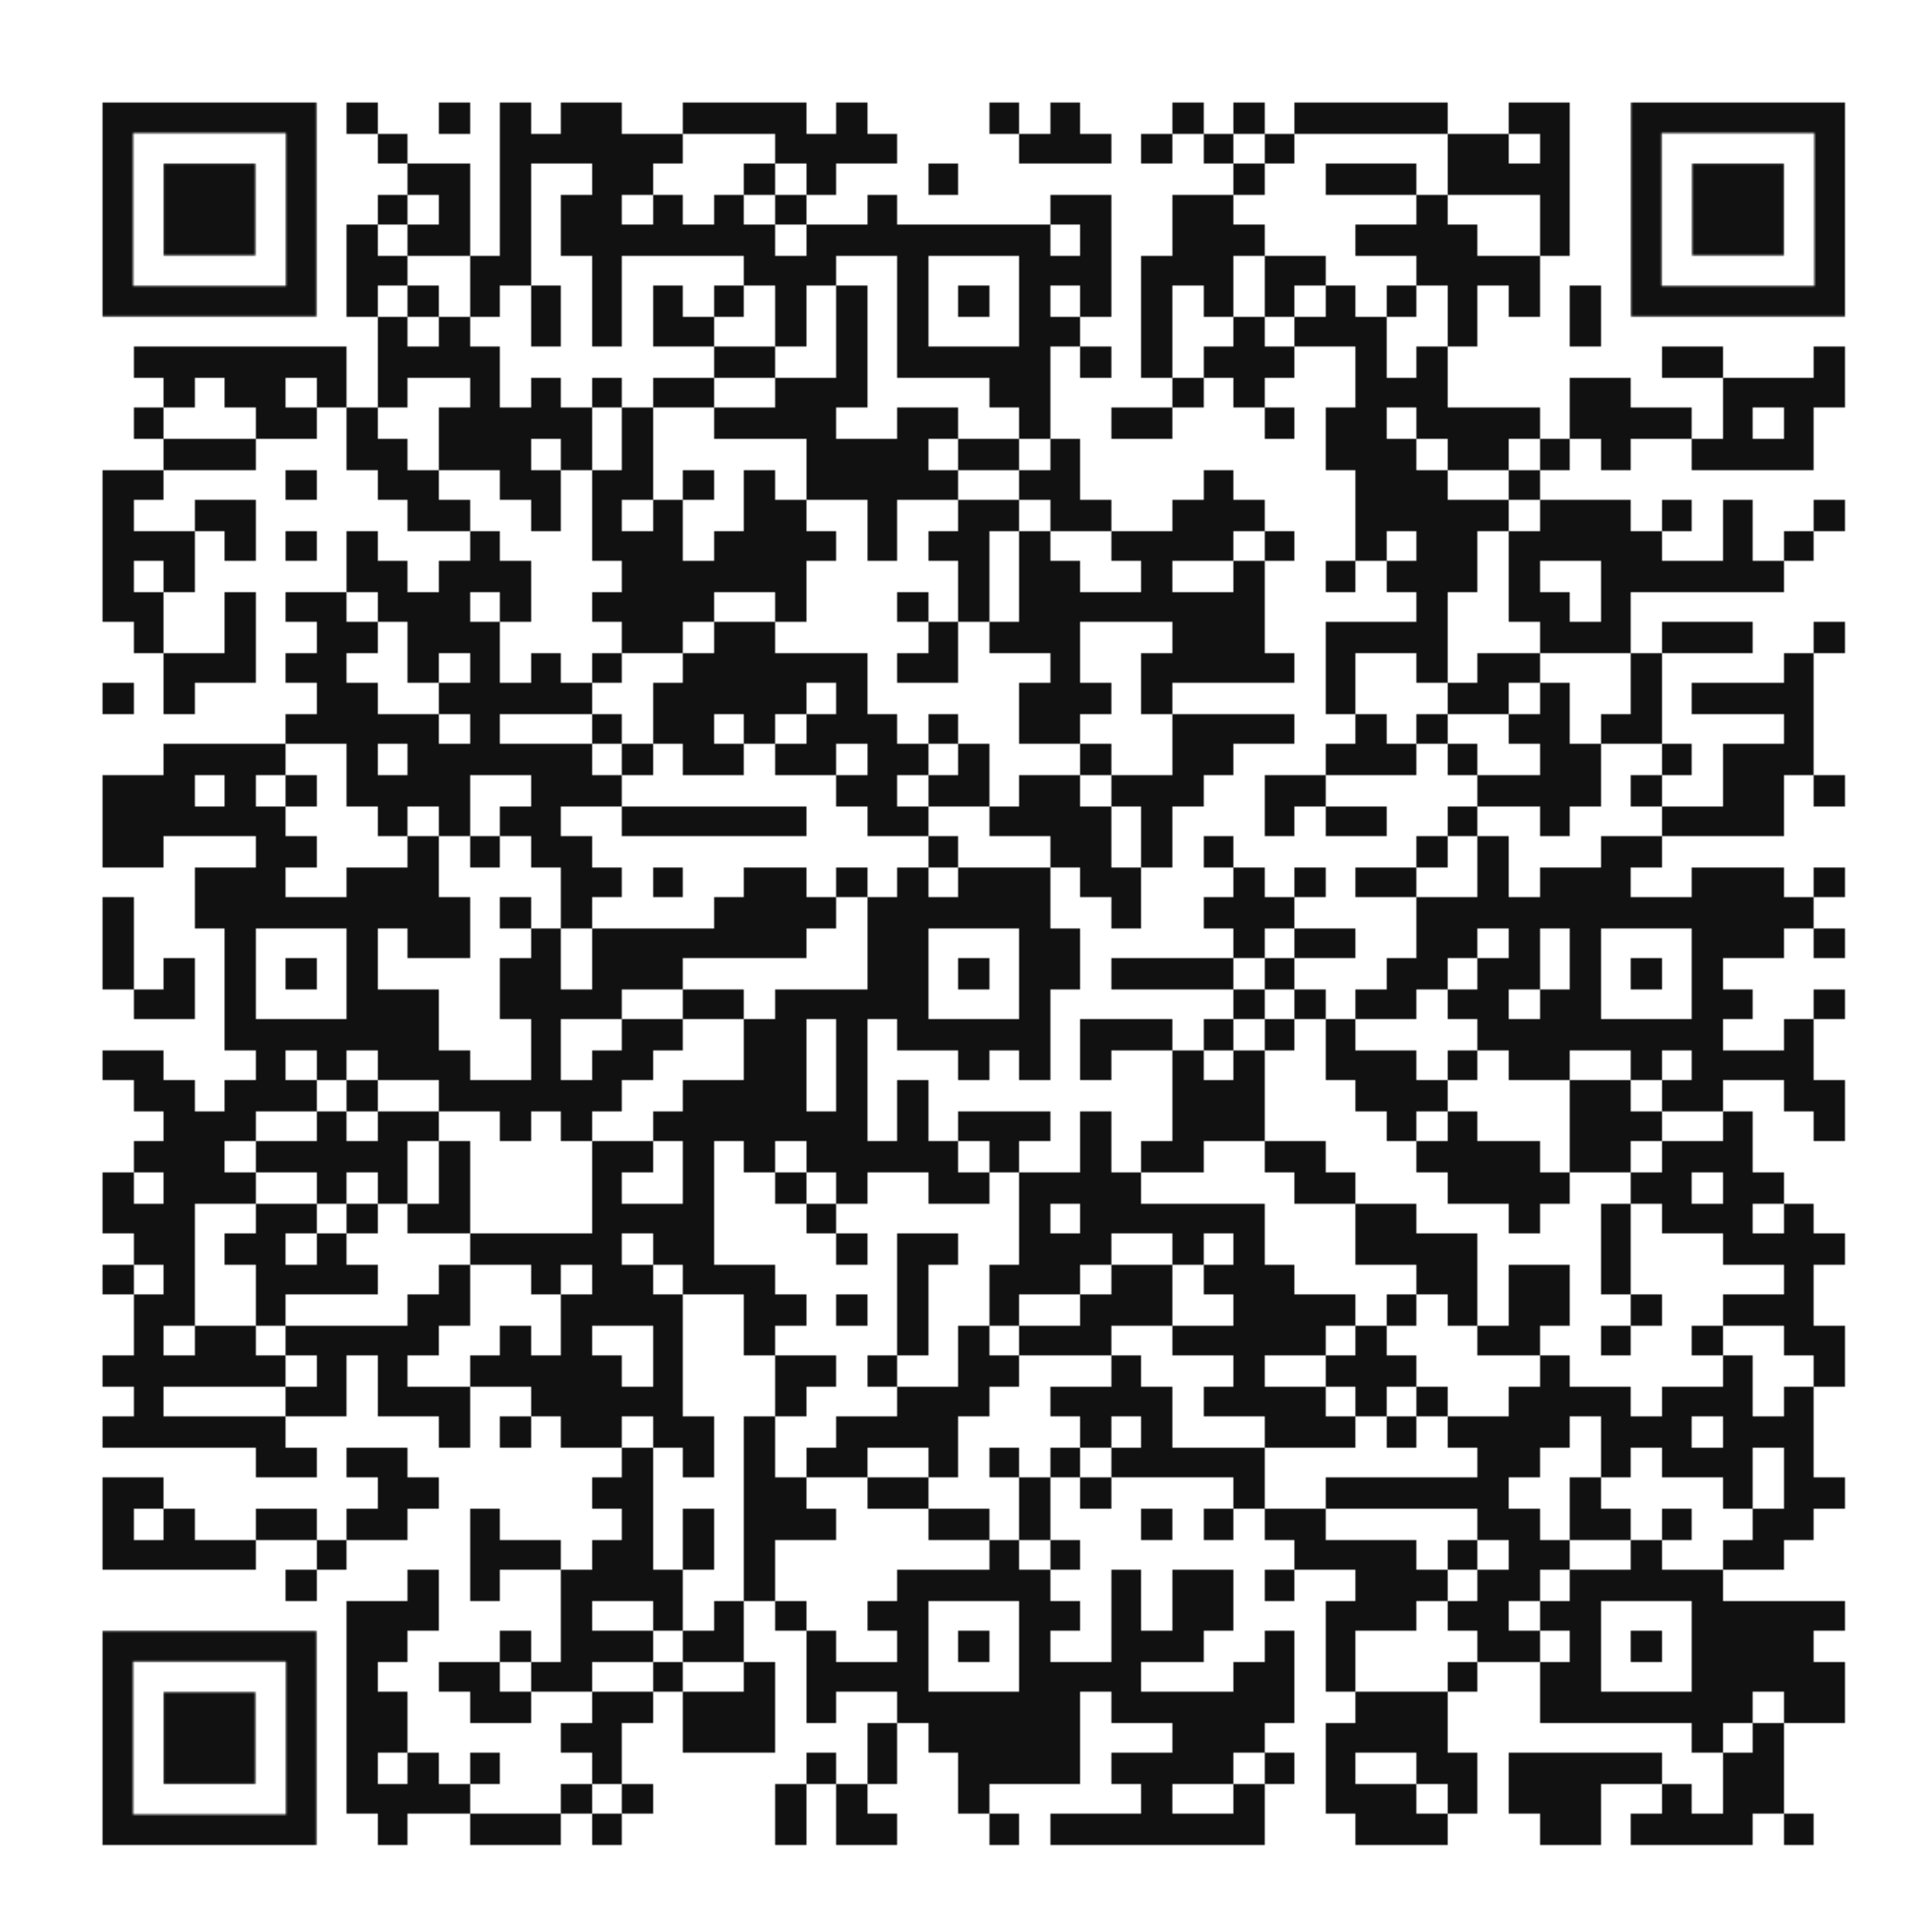

- Irish Childhood Bereavement Network How to support children

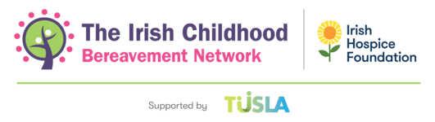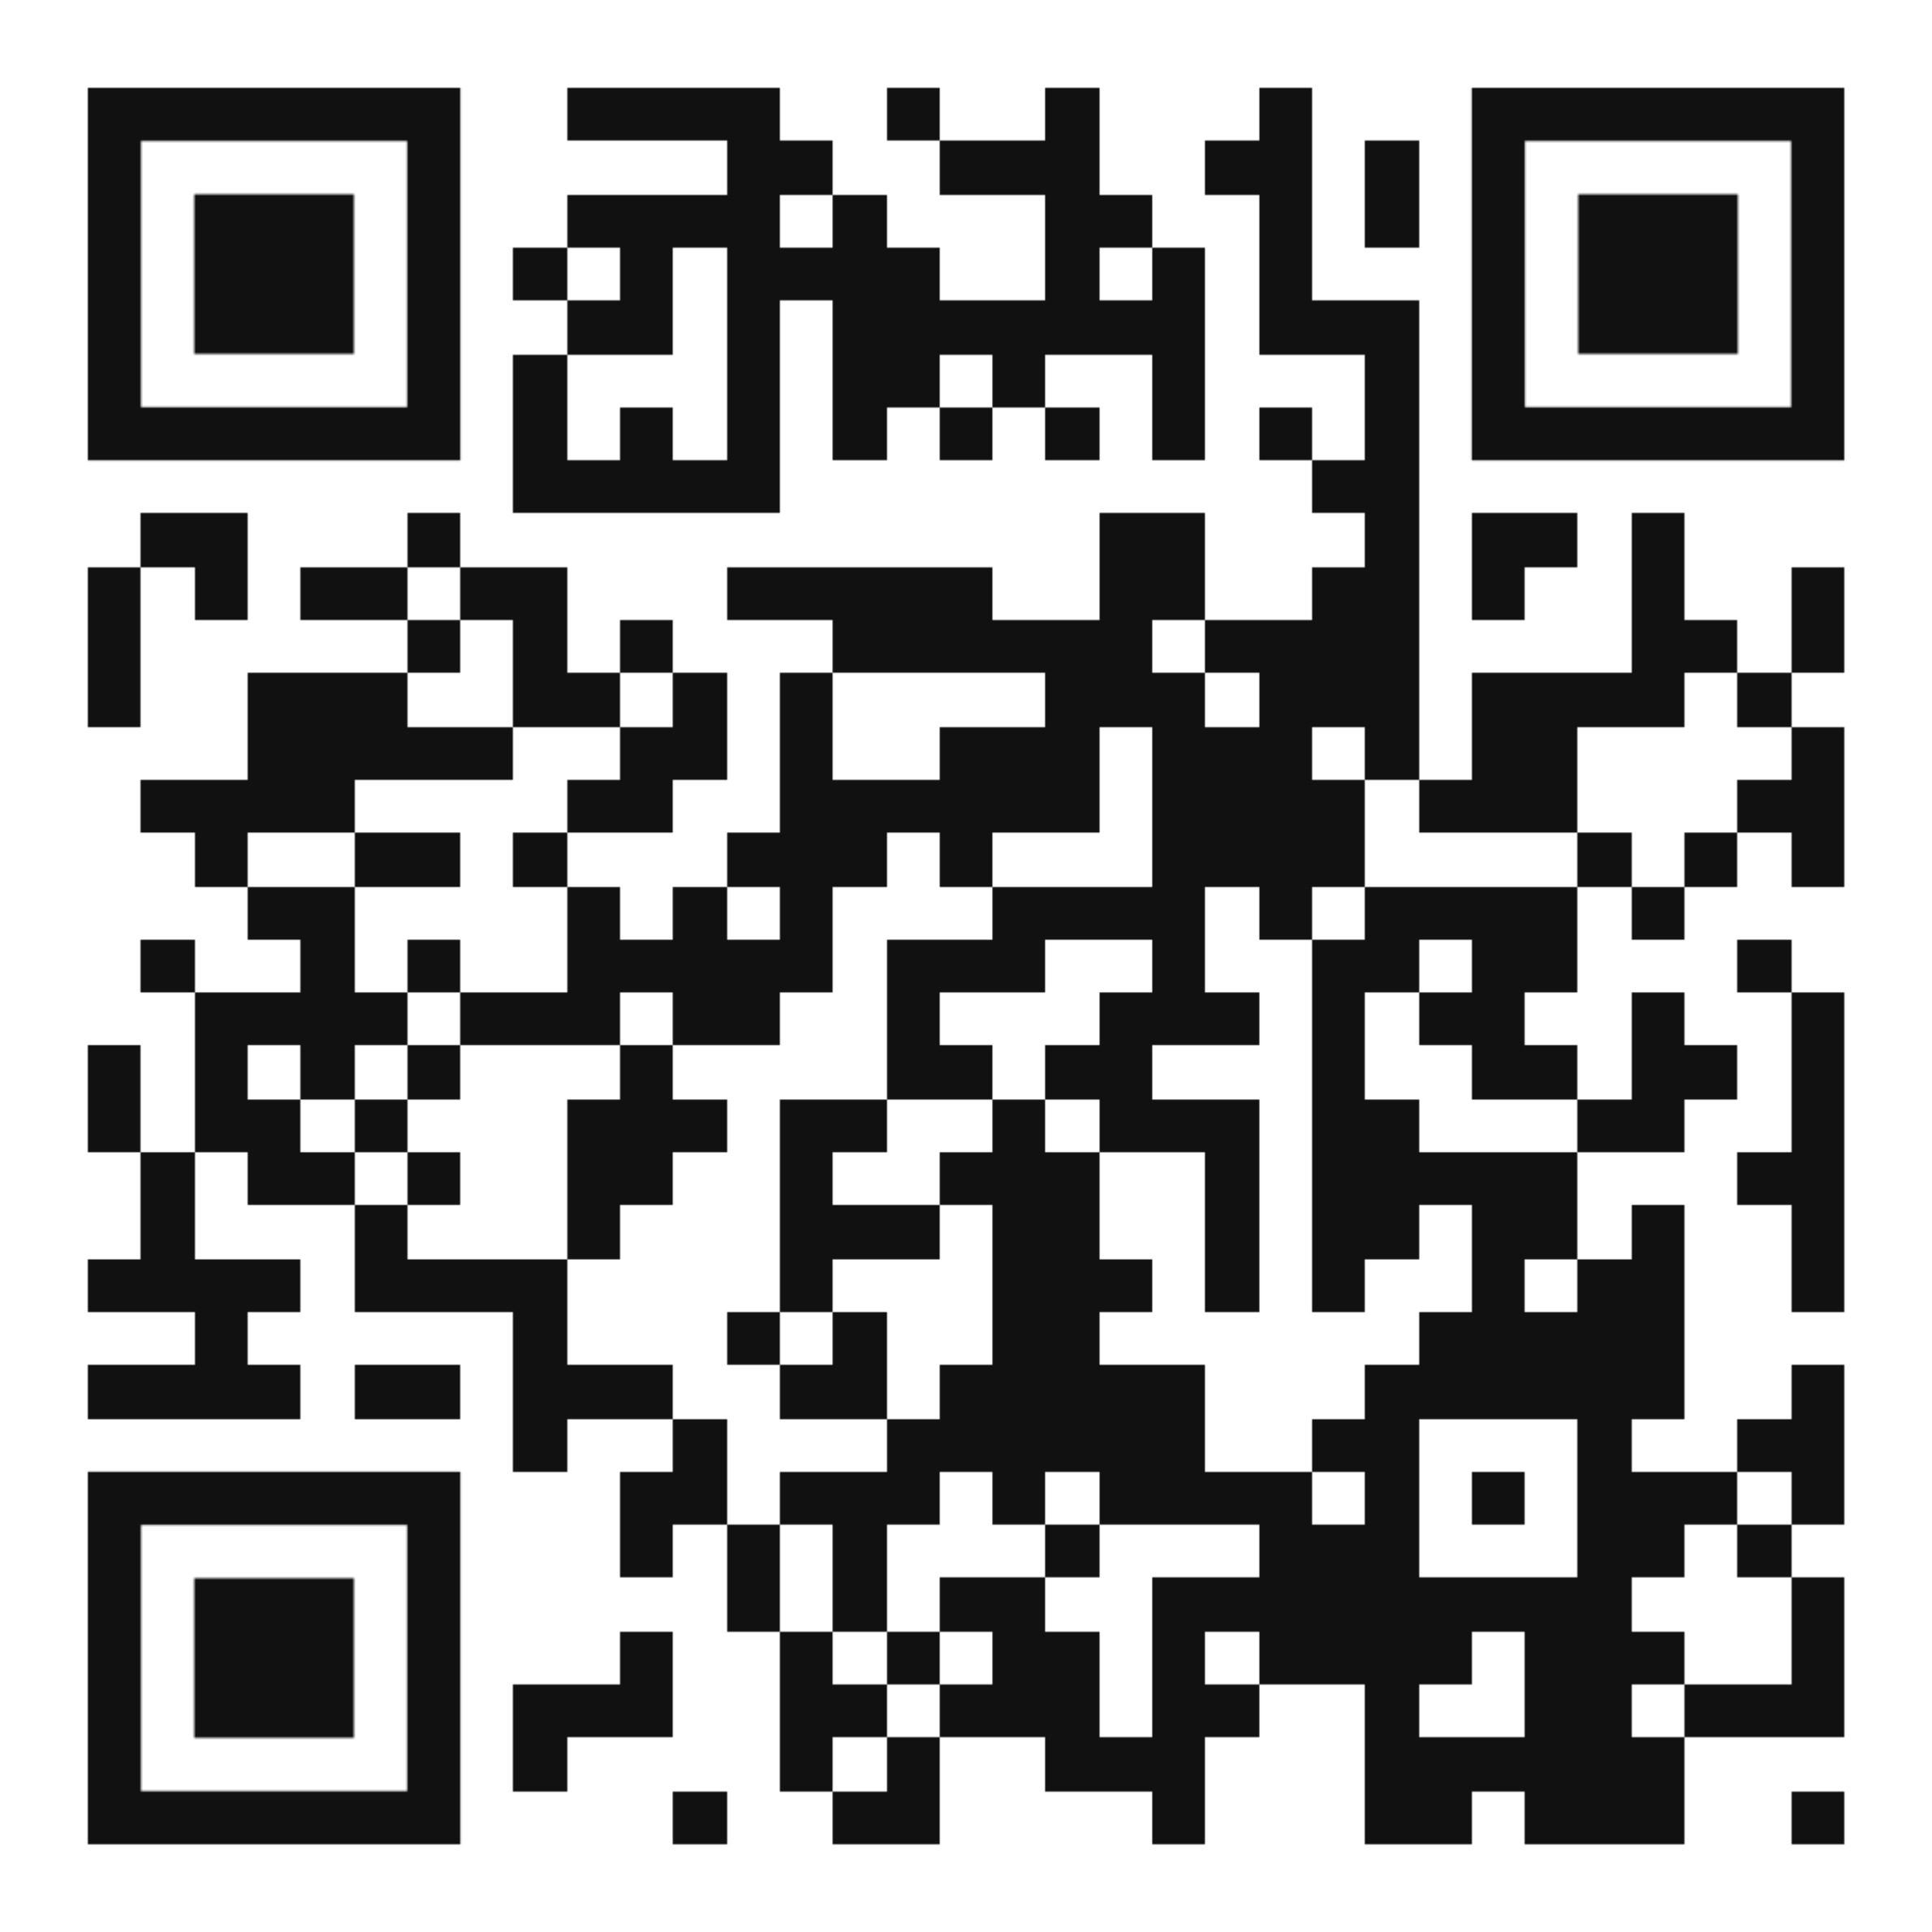

- Irish Hospice Foundation – Bereavement Support Line
1800 807077
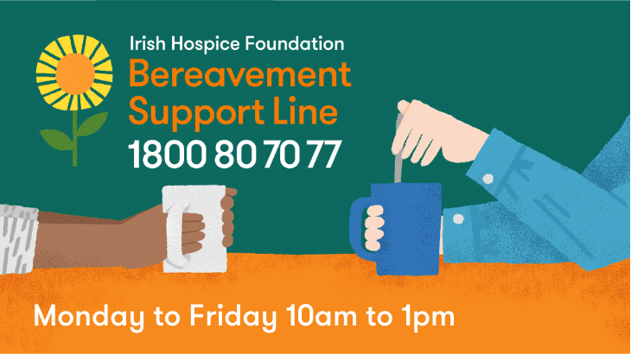

Date issued: November 2024
Review Date: November 2027
Author(s): End of Life Care Committee
Approved by: End of Life Care Committee



What Happens Next When Someone Close Dies



Information for Families

Available Support



- The Mortuary Staff are available to respond to any queries with regard to the care of your loved one in the mortuary. Contact 045 849577

- The Social Work Department at Naas General Hospital offer practical and emotional support. Contact 045 849736.

- The chaplaincy service is available to discuss spiritual and pastoral care issues. Contact 045 849637

- Citizens Information Service
Contact 0818 074000

- Irish Hospice Foundation: Bereavement Support Line Phone: 1800 807077 Mon-Fri (10am-1pm)

If there is a Post Mortem?

A member of the medical team will inform you if there is a possibility that a post mortem will take place. A post mortem is an examination of the body of a person who has died in order to verify the cause of death and/ or examine the effects of treatment.

A Coroner is informed in all cases of sudden, unexpected or unexplained deaths, or the death of a resident in long term care. If a Coroner orders a post mortem it must take place by law. In such circumstances a formal identification of the body of the deceased, with a member of an Garda Siochana present, will take place.

For more information on post mortems, please ask a member of staff for our Naas General Hospital Post Mortem Information booklet.

Visit: www.coroners.ie for further information about the Coroners service.

How to get a Death Certificate

Where a post mortem is not required our Patient Safety Department will issue a Death Notification Form. It is advisable to telephone the department in advance.
Patient Safety Telephone: 045 843106

Introduction

The death of a loved one is a sad and difficult time for families. We, the staff of Naas General Hospital wish to extend our sincere sympathy to you on the death of your loved one. We hope this leaflet will help you in the initial stages of your loss and guide you as to what will happen next.

What Happens Immediately After Death?

In most cases, some time can be spent with your loved one who has died on the ward/department. When you are ready to leave the hospital your loved one is brought to the hospital mortuary which is located on the grounds of Naas General Hospital. Your loved one will be cared for by our mortuary services staff.
If you wish to visit the hospital mortuary and see your loved one, we recommend that you telephone in advance to ensure that a viewing may be facilitated.
Mortuary Phone: 045 849577

Funeral Arrangements
We advise you to contact your local funeral director as early as possible. The funeral director will guide you through the next steps and assist you with the funeral arrangements. If cremation is your preferred option please let the ward staff know.

This notification form must be presented to the registrar in the civil registration office where you can register and obtain the death certificate. To book your appointment to register the death please go online www2.hse.ie/services/births-deaths-and-marriages/register/death/

There is no charge to register the death, but you will have to pay 20euro for the death certificate.
Contact Details: Births, Deaths and Marriages District Registration Office, Unit 5 Monread Office and Leisure Complex, Naas, Co Kildare Phone: 045 920180
NOTE: If the coroner requested a post mortem, the final death certificate will not be available until the coroner receives the post mortem report. An interim certificate will be provided by the Coroner’s office on request, which may be acceptable to banks, insurance companies and other institutions.

